Stage 4 – "Come quietly or there will be trouble"
COURSE DESIGNER: John Royer (Outdoor Dynamics)
SCORING: Comstock 22 rounds.
TARGETS: 11 cardboard targets.
SCORED HITS: 2 Best hits per carboard will be scored.

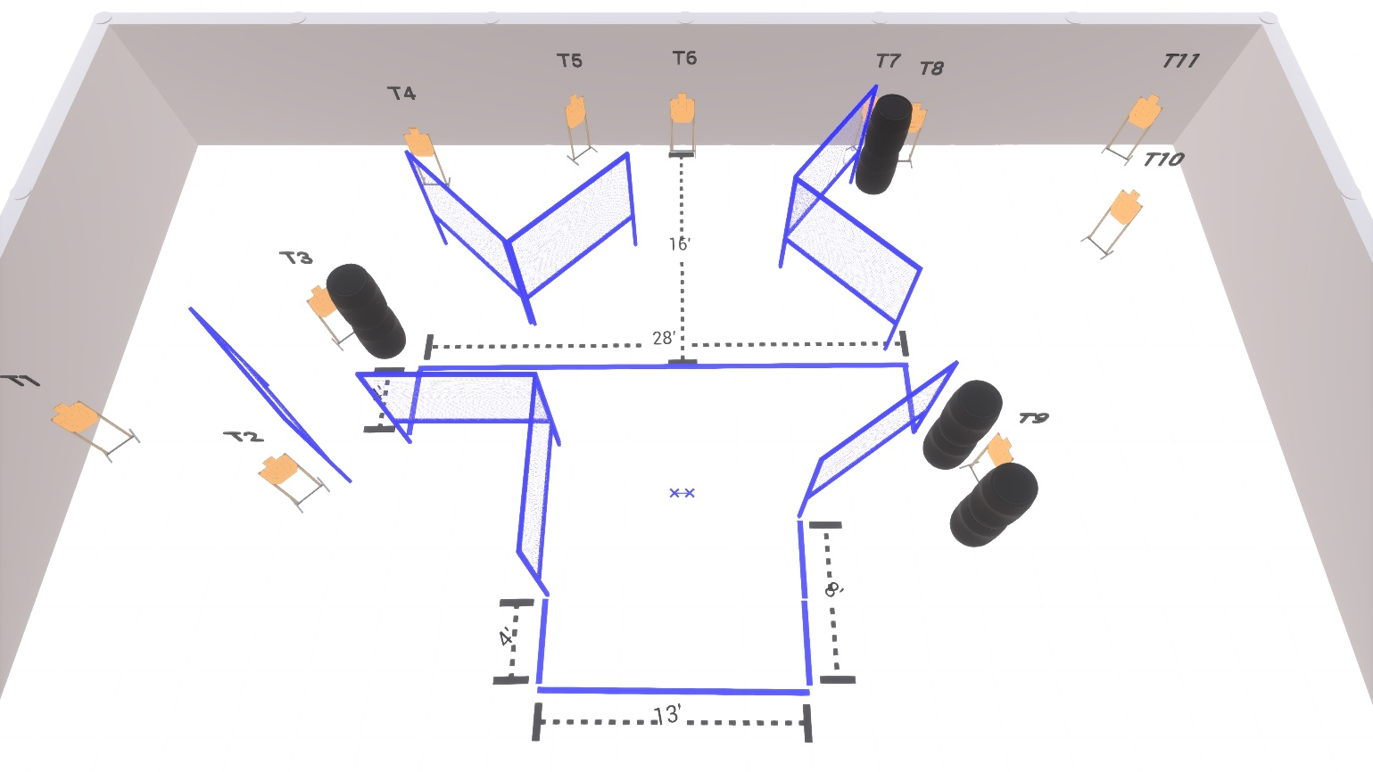

Written Stage Briefing:

Stage 4 – "Come quietly or there will be trouble" - is a 22 round, 110 point, Comstock Course. There are 11 cardboard targets.

Starting with both feet touching the Shooting Sports Innovations Xs
Handgun is loaded and holstered, wrists below belt.
PCC is loaded held in both hands, stock on belt.

On the audible start signal, engage targets from within the shooting area.

USPSA / NROI Range Commands:
- Make Ready
- Are you ready?
- Standby
- If finished, unload and show clear
- If clear, hammer down and holster (Handgun)
If clear, hammer down and flag (PCC)
If clear, cylinder closed and holster (Revolver)
- Range is clear

Setup Notes:
10 Single Wall Stands
3 Double Wall Stands
8 Full Walls
12 Target stands / 24 target sticks
8+ Barrels
1 Starting Xs



